Abdullrahman Alghanim

03/30/2025

LAB 09 - Protocol Hacking

CIS 4204

Exercise 1:

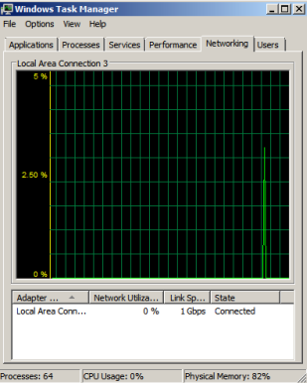

Exercise 2:

1.2195

The rest will the images below

Record the full URI requests of all the GET requests.

What kind of packet is packet number 1400?

What is the reference time stamp of packet number 1404?

. Export app_logo.png and find the MD5 hash of the file.

Export SD-Booster-v 1-eng.html and then record the email and Twitter contacts in the document.

. Export app_logo.png and find the MD5 hash of the file.

